|  |  |  |
| --- | --- | --- |
|  | October First Thursday Match  **Stage 3**  **Mostly Open Targets**  Designed by Ike Starnes  Credit to Brenda Taylor Hammer-Down Practical Shooters |  |
| **START POSITION:** Standing inside the shooting area.  **HANDGUN:** Handgun is loaded and holstered, both hands touching mark.  **PCC:** PCC is loaded, stock on belt, muzzle touching mark. | | **SCORING:** Comstock, 28 rounds, 140 points  **TARGETS:** 14 USPSA paper targets  **SCORED HITS:** 2 Best hits per target will be scored  **START-STOP:** Audible - Last shot  **RULES:** Current USPSA Rules |
| **STAGE PROCEDURE:** Engage targets from within the shooting area. | |

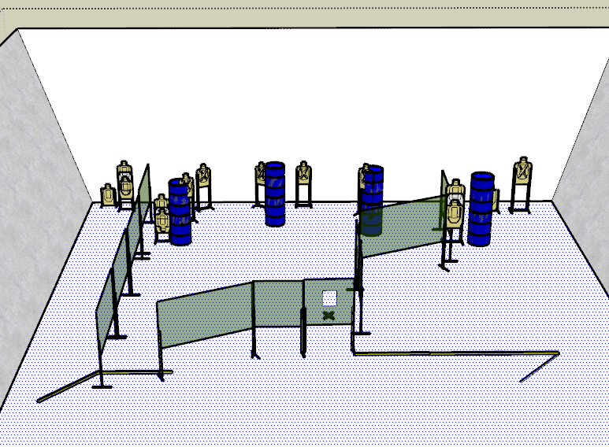

**WRITTEN STAGE BRIEFING:**

**Stage 3 – Mostly Open Targets** is a 28-round, 140 point, Comstock Long Course. There are 14 USPSA targets and the best 2 hits per target will be scored.

**Handgun start position** is standing inside the shooting area with both hands touching the mark. The handgun is loaded and holstered.

**PCC start position** is standing anywhere inside the shooting area with stock on belt and muzzle touching the mark.

On the audible start signal, engage targets from within the shooting area.